Course Two

Go Beyond the Numbers: Translate Data into Insights


Instructions
Use this PACE strategy document to record decisions and reflections as you work through this end-of-course project. You can use this document as a guide to consider your responses and reflections at different stages of the data analytical process. Additionally, the PACE strategy documents can be used as a resource when working on future projects.

Course Project Recap
Regardless of which track you have chosen to complete, your goals for this project are:
- Complete the questions in the Course 2 PACE strategy document
- Answer the questions in the Jupyter notebook project file
- Clean your data, perform exploratory data analysis (EDA)
- Create data visualizations
- Create an executive summary to share your results

Relevant Interview Questions
Completing the end-of-course project will help you respond to these types of questions that are often asked during the interview process:
- How would you explain the difference between qualitative and quantitative data sources?
- Describe the difference between structured and unstructured data.
- Why is it important to do exploratory data analysis?
- How would you perform EDA on a given dataset?
- How do you create or alter a visualization based on different audiences?
- How do you avoid bias and ensure accessibility in a data visualization?
- How does data visualization inform your EDA?
Reference Guide
This project has six tasks; the visual below identifies how the stages of PACE are incorporated across those tasks.
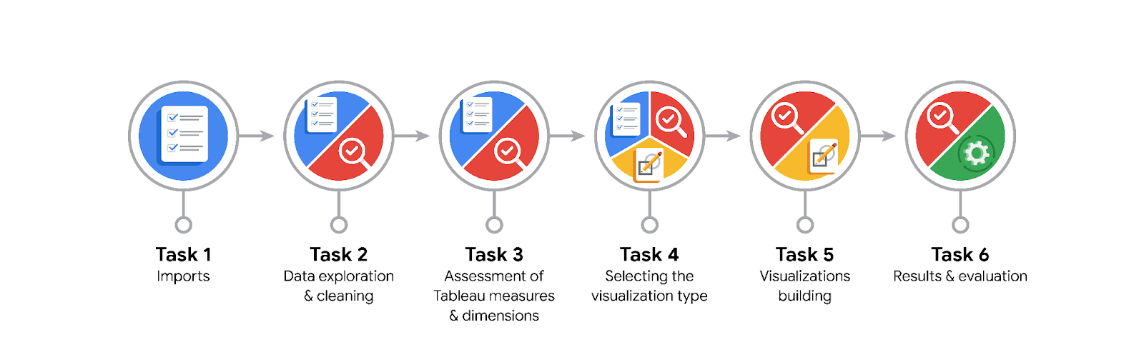
Data Project Questions & Considerations

PACE: Plan Stage
- What are the data columns and variables and which ones are most relevant to your deliverable?
Data columns: claim_status, video_id, video_duration_sec, video_transcription_text, verified_status, author_ban_status, video_view_count, video_like_count, video_share_count, video_comment_count, and video_download_count.
Most relevant: claim_status, video_duration_sec, verified_status, author_ban_status, video_view_count, video_like_count, video_share_count, and video_comment_count.

- What units are your variables in?
Video_duration_sec is in seconds, other variables with the _count suffix represent the number of occurences.

- What are your initial presumptions about the data that can inform your EDA, knowing you will need to confirm or deny with your future findings?
There should be a strong correlation between a videos’ engagement level and claim status based on the data summary in course 1.
Other variables such as author_ban_status and verified_status can also tell a video’s likelihood of representing claims.
Certain videos in our dataset can also have exceptionally high levels of engagement, which are outliers that could be removed for future analysis.

- Is there any missing or incomplete data?
There are 298 rows of missing data in columns claim_status, video_transcription_text, and all the counter metrics.

- Are all pieces of this dataset in the same format?
There are 3 variables of type int64, 4 variables of type object, and 5 variables of type float64. The values of each column in the dataset belong to the same data type.

- Which EDA practices will be required to begin this project?
The plan stage of this project requires identifying outliers with describe() and boxplots to determine whether these outliers should be kept, reassigned or removed

PACE: Analyze Stage
- What steps need to be taken to perform EDA in the most effective way to achieve the project goal?
  - Import basic Python packages like pandas, numpy, matplotlib.pyplot, and seaborn.
  - Load the dataset into a DataFrame with pandas
  - Assess the data shape with pandas.shape, determine the range of values in numeric columns & count the number of values in categorical with pandas.describe() and pandas.value_counts()
  - Create visualizations for the counter metrics and video duration
  - Identify outliers with the IQR range and boxplots

- Do you need to add more data using the EDA practice of joining? What type of structuring needs to be done to this dataset, such as filtering, sorting, etc.?
No additional datasets have been mentioned so data joining is not under consideration in this stage. Filtering null values and grouping data based on claim_status or author_ban_status is important to determine certain correlations between variables.

- What initial assumptions do you have about the types of visualizations that might best be suited for the intended audience?
  - Visualizations should describe the distribution of numeric variables (across different categorical variables), represent the percentage of values in a column, compare the relationship between numeric variables.
  - Visualizations should have appropriate colors, bin size (for histograms), and provide adequate explanation for the general audience.

PACE: Construct Stage
- What data visualizations, machine learning algorithms, or other data outputs will need to be built in order to complete the project goals?
  - Histograms and boxplots can describe the distribution of numeric variables across different categorical variables
  - Pie charts can represent the percentage of a certain value in a column.
  - Scatterplots can compare the relationship between numeric variables.

- What processes need to be performed in order to build the necessary data visualizations?
Environment setup of necessary Python libraries, initial inspection, data cleaning and plot visualization

- Which variables are most applicable for the visualizations in this data project?
  - Categorical variables: claim_status and author_ban_status
  - Numerical variables: video count metrics and video_duration_sec

- Going back to the Plan stage, how do you plan to deal with the missing data (if any)?
Since the dataset has almost 20000 records with less than 300 of them containing null values, it would be justifiable to remove these records without reducing the effectiveness of future analysis.

PACE: Execute Stage
- What key insights emerged from your EDA and visualizations(s)?
  - Claim videos accumulate significantly higher counts across all 5 engagement metrics
  - Data for these engagement variables, except view count, is heavily right skewed with certain videos going viral.
  - Claim videos appear much more frequently among restricted accounts.

- What business and/or organizational recommendations do you propose based on the visualization(s) built?
  - Since a majority of videos with high engagement represent claims, these videos should be prioritized in the moderation queue, if they are put under review.
  - The development of a machine learning model is recommended to reduce the workload for human moderators handling a large number of videos.

- Given what you know about the data and the visualizations you were using, what other questions could you research for the team?
  - Analyze the specific ratio of engagement metrics to one another, for instance like count and comment count, in different video or author categories
  - Figure out the reason behind null records, in particular determine whether the proportion of claim status and author ban status in these records might explain if these videos have banned authors or violate TikTok’s rules.

- How might you share these visualizations with different audiences?
  - Use the Python Jupyter Notebook to share the results with the Data Science Team
  - Focus on the business impact with a Tableau dashboard or seaborn visualizations by comparing distributions when representing results to stakeholders or the Management Team

